19. Designing and implementing a data warehouse for analytics and reporting.
create database if not exists sale_datawarehouse;
use sale_datawarehouse;

drop table if exists fact_sale;
drop table if exists dim_customer;
drop table if exists dim_product;
drop table if exists dim_date;
drop table if exists dim_location;

create table dim_customer (
customer_key int auto_increment primary key,
customer_id int,
customer_name varchar(100),
gender varchar(10),
age int
);

create table dim_product (
product_key int auto_increment primary key,
product_id int,
product_name varchar(100),
category varchar(50),
price decimal(10,2)
);

create table dim_date (
date_key int primary key,
full_date date,
day int,
month int,
month_name varchar(20),
quarter int,
year int
);

create table dim_location (
location_key int auto_increment primary key,
city varchar(50),
state varchar(50),
country varchar(50)
);

create table fact_sale (
sale_key int auto_increment primary key,
customer_key int,
product_key int,
date_key int,
location_key int,
quantity int,
sales_amount decimal(12,2),

foreign key (customer_key)
references dim_customer(customer_key),

foreign key (product_key)
references dim_product(product_key),

foreign key (date_key)
references dim_date(date_key),

foreign key (location_key)
references dim_location(location_key)
);

insert into dim_customer
(customer_id,customer_name,gender,age)
values
(101,'Gauri','female',22),
(102,'Rahul','male',25),
(103,'Bhavana','female',28),
(104,'Jayant','male',30),
(105,'Nidhi','female',26);
select*from dim_customer
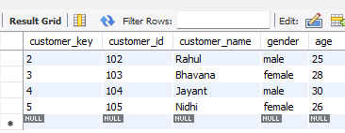

insert into dim_product
(product_id,product_name,category ,price)
values
(1,'Laptop','Electronics',55000),
(2,'Mobile','Electronics',20000),
(3,'Mouse','Accessories',500),
(4,'Keyboard','Accessories',1200),
(5,'Headphones','Accessories',1500);
select*from dim_product

insert into dim_date
(date_key,full_date,day,month,month_name,quarter,year)
values
(20260105,'2026-01-05',5,1,'January',1,2026),
(20260110,'2026-01-10',10,1,'January',1,2026),
(20260205,'2026-02-05',5,2,'February',1,2026),
(20260210,'2026-02-10',10,2,'February',1,2026),
(20260305,'2026-03-05',5,3,'March',1,2026),
(20260310,'2026-03-10',10,3,'March',1,2026),
(20260315,'2026-03-15',15,3,'March',1,2026);
select*from dim_date

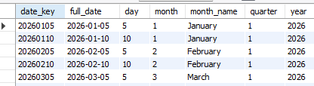

insert into dim_location
(city,state,country)
values
('Mumbai','Maharashtra','India'),
('Pune','Maharashtra','India'),
('Nagpur','Maharashtra','India');
select*from dim_location
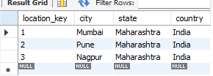
insert into fact_sales2
(customer_key,product_key,date_key,location_key,
quantity,sales2_amount)
values
(1,1,20260105,1,1,55000),
(2,2,20260110,2,2,40000),
(3,3,20260205,3,3,1500),
(4,4,20260210,2,2,2400),
(5,5,20260305,3,2,3000),
(1,2,20260310,1,1,20000),
(2,1,20260315,2,1,55000),
(3,3,20260315,3,4,2000),
(4,2,20260305,2,1,20000),
(5,1,20260310,3,1,55000);
select*from fact_sales2
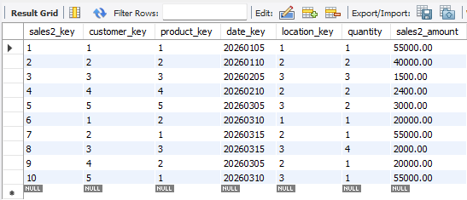
select
p.category,
sum(f.quantity) as total_units,
sum(f.sales2_amount) as total_sales2
from fact_sales2 f
join dim_product p
on f.product_key=p.product_key
group by p.category
order by total_sales2 desc;
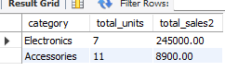
select
d.year,
d.quarter,
sum(f.sales2_amount) as quarterly_sales2
from fact_sales2 f
join dim_date d
on f.date_key=d.date_key
group by d.year,d.quarter
order by d.year,d.quarter;
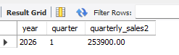
select
c.customer_name,
sum(f.sales2_amount) as total_sales2
from fact_sales2 f
join dim_customer c
on f.customer_key=c.customer_key
group by c.customer_name
order by total_sales2 desc
limit 1;
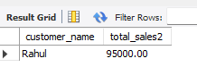
select
p.product_name,
sum(f.quantity) as units_sold
from fact_sales2 f
join dim_product p
on f.product_key=p.product_key
group by p.product_name
order by units_sold desc
limit 1;
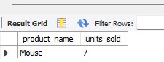
select
l.city,
sum(f.sales2_amount) as total_sales2
from fact_sales2 f
join dim_location l
on f.location_key=l.location_key
group by l.city
order by total_sales2 desc;
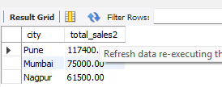
select
d.year,
d.month,
d.month_name,
sum(f.sales2_amount) as monthy_sales2
from fact_sales2 f
join dim_date d
on f.date_key=d.date_key
group by d.year,d.month,d.month_name
order by d.year,d.month;
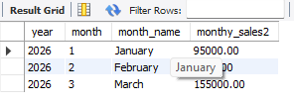
select
p.category,
sum(f.quantity) as total_units,
sum(f.sales2_amount) as total_sales2
from fact_sales2 f
join dim_product p
on f.product_key=p.product_key
group by p.category
order by total_sales2 desc;
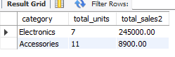
select
sum(sales2_amount) as total_sales2
from fact_sales2;
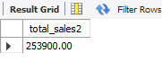
select
p.product_name,
p.category,
sum(f.quantity) as total_quantity,
sum(f.sales2_amount) as total_sales2
from fact_sales2 f
join dim_product p
on f.product_key=p.product_key
group by p.product_name,p.category
order by total_sales2 desc;

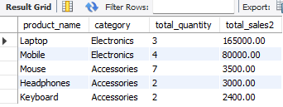

select
c.customer_name,
sum(f.sales2_amount) as total_spending
from fact_sales2 f
join dim_customer c
on f.customer_key=c.customer_key
group by c.customer_name
order by total_spending desc;

